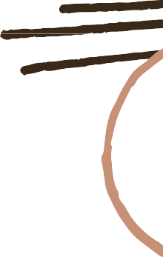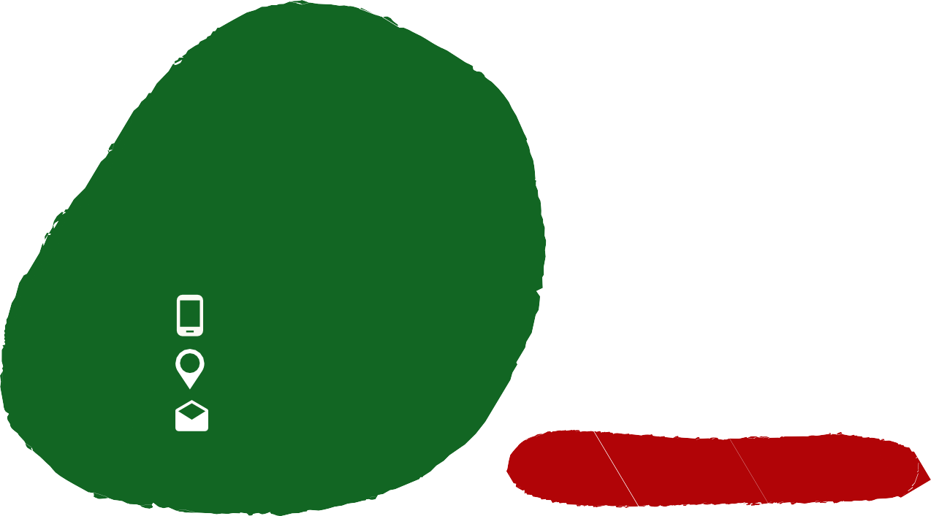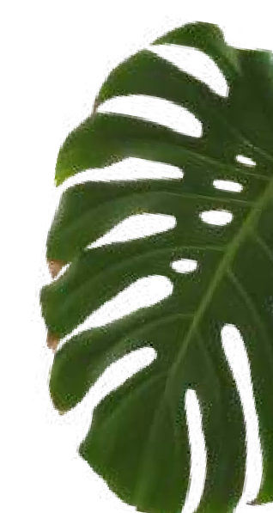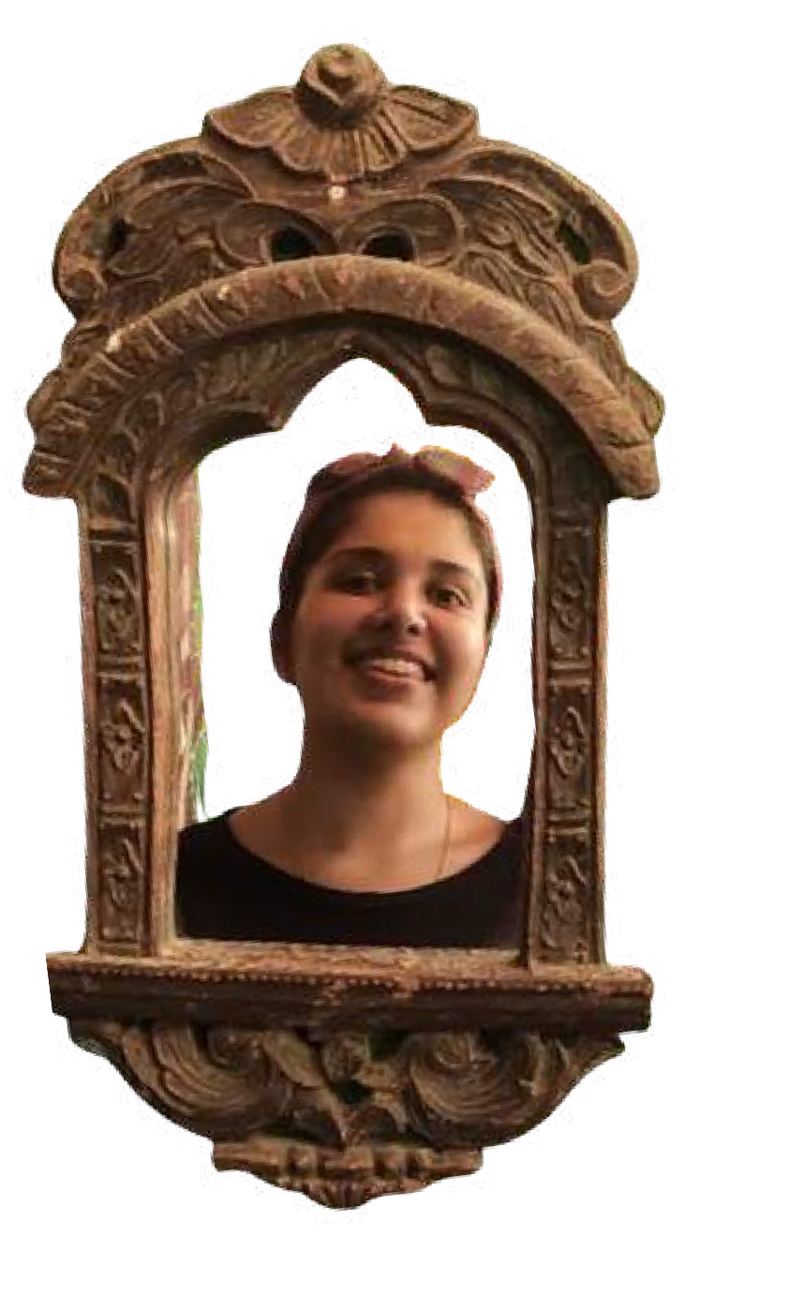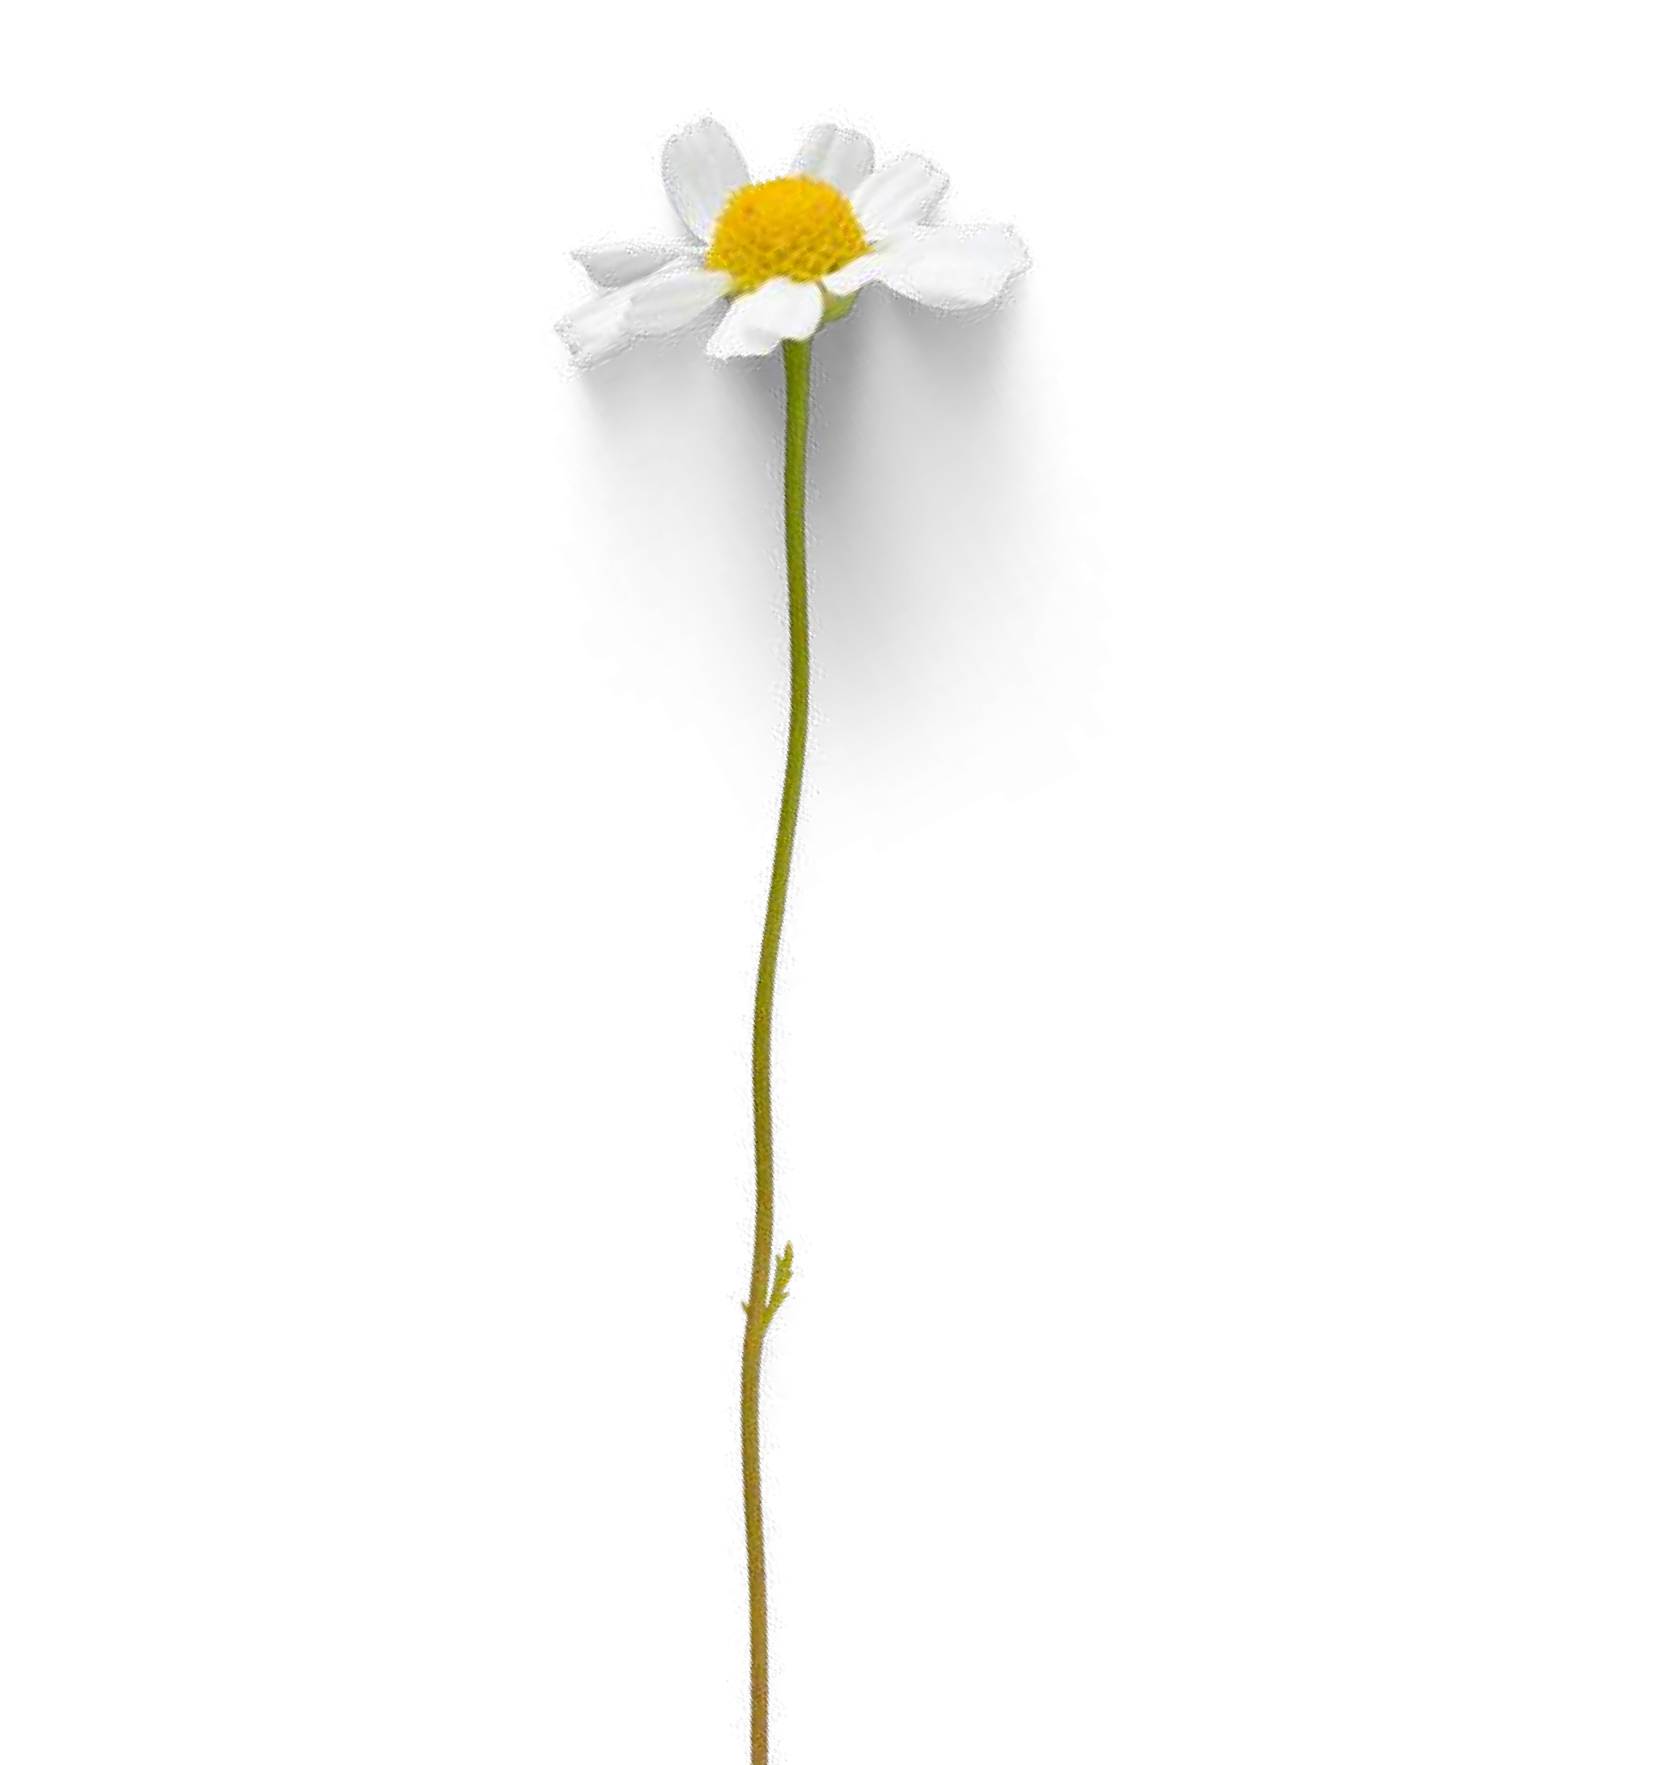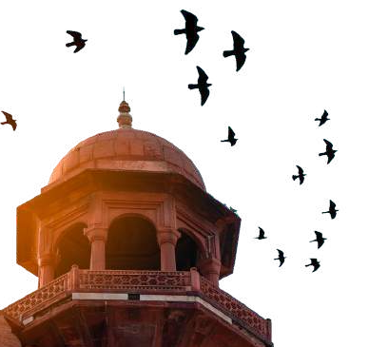SAMINA
RANGWALA

UI/UX/GRAPHIC
DESIGNER

+91 9881051555

Mumbai, India sabooo88@gmail.com

I am passionate about creating visually stunning designs that help brands grow. I possess more than 7 years of quality experience in designing outstanding digital and print campaigns, websites, mobile app UI/UX, social media posts and much more, I think I could be a great addition to your Company as a Sr. UI/UX/Graphic Designer.

DESIGN SKILLS
Logo Creation & Branding Presentations
UI / UX Design Print Media Product Packaging Social Media Mobile App Design
Layout design for brochures, posters, magazines,
and reports

MY EDUCATION
CA | M.COM | B.COM

VIEW MY WORK
CLICK HERE

MY EXPERIENCE

SENIOR GRAPHIC DESIGNER

LOM Digital Jan 2022 - Present
Working on a range of print, interactive and digital design projects.
Managing Junior Design Artists and reviewing their work
Client and Print Media Coordination

UI/UX/GRAPHIC DESIGNER
RethinkingWeb Oct 2017 - Present Responsible for all the UI/UX Design for Web and Mobile Apps

JUNIOR GRAPHIC DESIGNER
3 Pencils March 2016 - Jan 2018 Responsible for social media designs for various clients and Print Media

INTERN
The Anthill Nov 2015 - Jan 2016 Responsible for Social Media Designs and creation of vectors

